IOT Paralysis Patient Health Care Project

The IOT based paralysis patient health care system is a system designed to help the patient convey various messages to doctors, nurse, or his/her loved ones sitting at home or office over the internet. The system makes use of a microcontroller based circuitry to achieve this functionality. It makes use of a hand motion recognition circuit and a receiver plus transmitter circuit. The hand motion circuit is used to detect hand movements using accelerometer+gyro and then transmit this information wirelessly over rf to the receiver system. The receiver system is designed to receive and process these commands and display them over the LCD display as well as transmit the data online over to IOT gecko server. The IOTgecko server then displays this information online, to achieve the desired output.

Block Diagram:

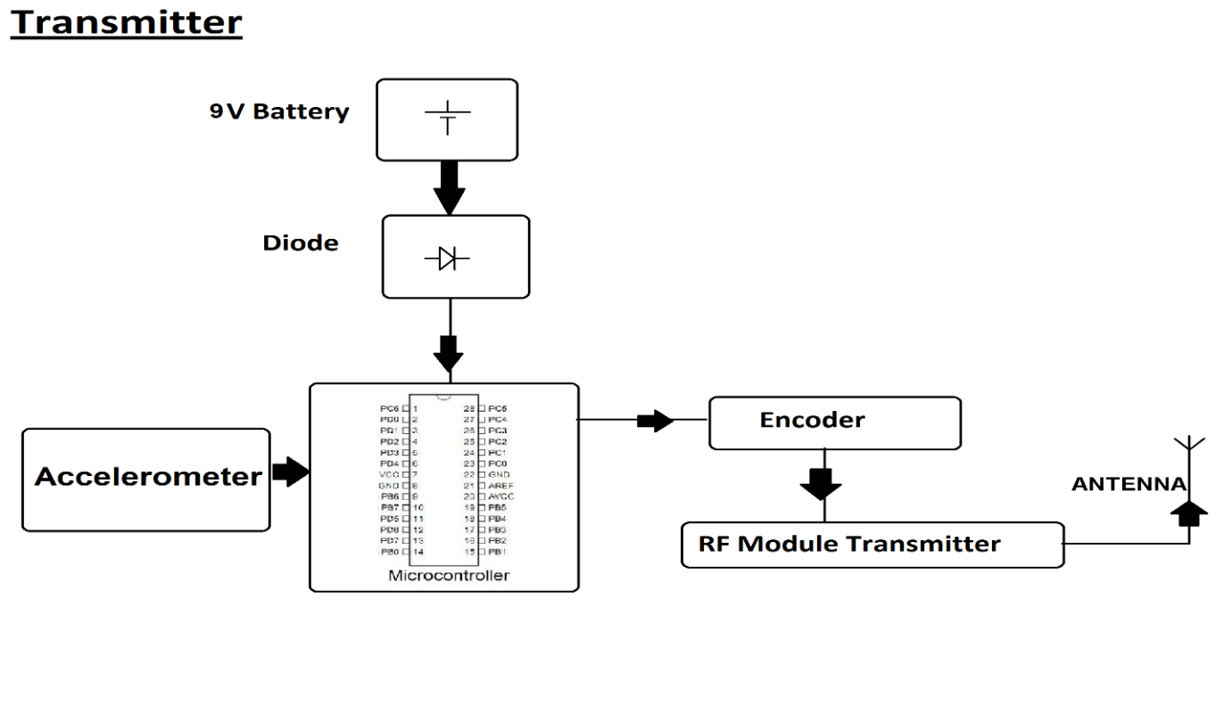

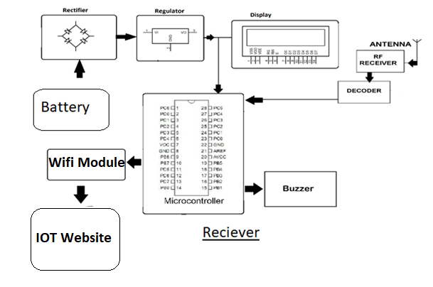
Hardware Specifications

- Atmega Microcontroller
- Accelerometer & Gyro
- ESP8266 Wifi Module

- RF Tx Rx

- LCD Display
- Crystal Oscillator

- Resistors

- Capacitors
- Transistors

- Cables and Connectors

- Diodes
- PCB and Breadboards

- LED

- Transformer/Adapter
- Push Buttons

- Switch

- IC
- IC Sockets

Software Specifications

- Arduino Compiler
- MC Programming Language: C

